Haydn Primary and Nursery School
Welcome to Foundation 2
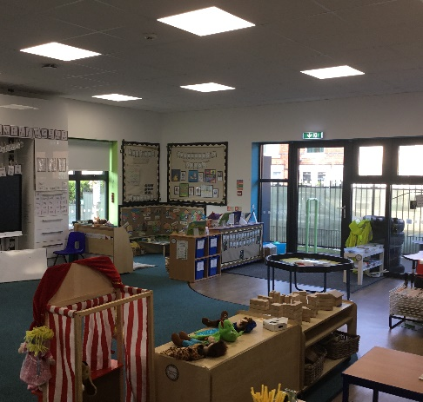
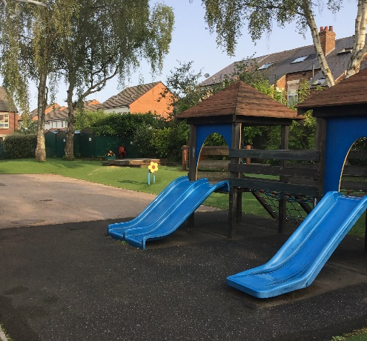

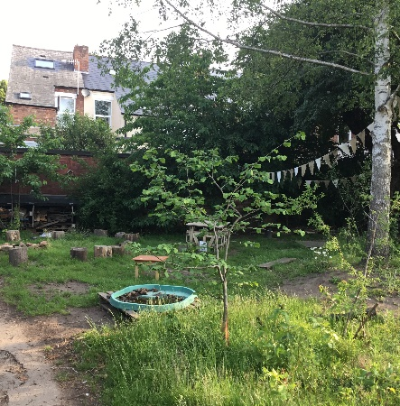
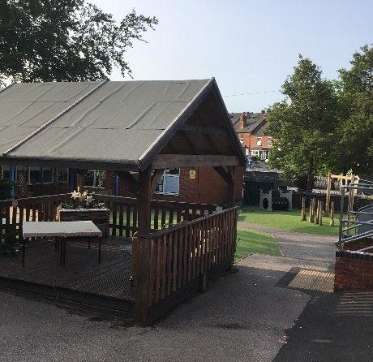

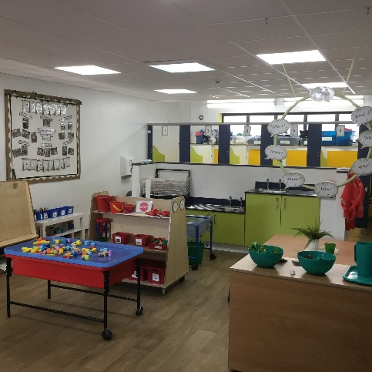
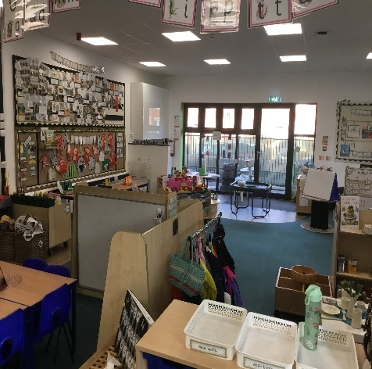

2025-26

Welcome
We wish to welcome you and your child to Haydn Primary School Early Years Foundation Stage (F2).
We are looking forward to a very exciting year ahead! Starting school is a major stepping stone in any child’s life and it is our intention to make your child’s transition from home, nursery or pre-school as smooth and as special as possible. Our main focus in the first few weeks will be helping your child to settle in and build new relationships with both the children and the adults in the setting.
Meet the Staff
Reception will be in two classes each with a teacher and a teaching assistant.

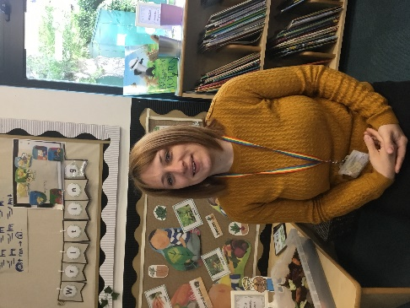

Mrs Ward
Early Years Lead & F2 Teacher

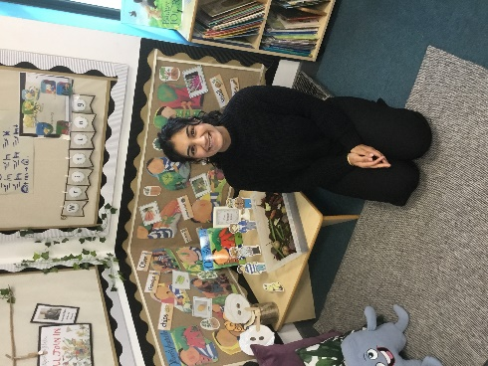

Mrs Sharma
F2 Teacher

Transition to School
We have a variety of strategies in place to ensure your child has a settled start to their school life. Firstly, we feel it is important that we get to know all about your child before they start school. The more we know, the more we can plan for their interests and needs in order to help them to feel happy and safe in school.
The main educators in your child’s life is yourselves! You know your child better than anybody else and we are sure that you have already provided them with a wealth of love and experience to help your child develop into a successful learner.
Welcome Meeting
A welcome meeting for parents/carers will be held in June, this will give you the opportunity to go through the brochure with the F2 staff.
Also, in your welcome pack you will find an Admission Form and an ‘All About Me’ booklet, this helps us to build a picture of your child and plan provision and activities centred around their interests and needs. These need to be returned to the school office by Friday 27th June 2025. The office will also need to take a copy of your child’s birth certificate so please bring these along when you hand in the admissions form.
Phone Calls
We will be contacting parents/carers of children who do not already attend Haydn Primary School Nursery on either Monday 16th June or Friday 20th June to have a chat about your child. This call will give you the opportunity to share information about your child and tell us anything that you feel we should know before your child starts school in September. It will also be a chance for us to get to know each other.
Visits
Your child will be offered a morning/afternoon visit to F2 where your child will meet the teachers and be given time to explore their new learning environment. Your child’s visit will be on Tuesday 1st July at the time specified in your letter. Parents/carers are invited to stay with their child for the first 15 minutes to settle them into the F2 space. After this time, we would like your child to have time to explore the setting independently and begin to form relationships with the staff, we find if parents/carers are present, often the child is more reluctant to do this.

Class Dojo
Week commencing 14th July we will be sending you an email to inform you who your child’s class teacher will be in September, the email will also contain a link to join our Class Dojo page. This will be an additional way for us to keep in touch with you, share updates of your child and share important messages. Prior to your child starting school with us in September we will be posting videos and messages for your child to view.
Arrangements for Starting School in September
Your child will be starting in F2 at Haydn Primary School on Wednesday 3rd September, the first two days will be half days - 8.45am until 11.30am. On the Friday your child is invited to stay for lunch so they will need to be collected at 12.45pm. A free hot school dinner will be provided for your child, alternatively, you could send your child with a packed lunch if you prefer this option. These shorter days ensure a smooth transition into school, offering your child the opportunity to make friends and experience time in F2 but also gives them time to recuperate at home in the afternoon after their busy morning! Your child will start full-time school on Monday 8th September 2025, 8.45am until 3.15pm.
Date | Mrs Ward’s class - FW | Mrs Sharma’s class - FS
Wednesday 3rd and Thursday 4th September | Attend morning  8.45am – 11.30am | Attend morning  8.45am – 11.30am
Friday 5th September | Attend morning session and for lunch  8.45am – 12.45pm | Attend morning session and for lunch  8.45am – 12.45pm
Monday 8th September | Full days begin  8.45am – 3.15pm | Full days begin  8.45am – 3.15pm

What does Haydn Primary School Offer
- Lots of time to explore the classroom – we call this Exploring Time! This is the opportunity for your child to choose the activities they complete in the classroom. An adult is also close by to support learning.
- A Forest School session each week – this is led by our Forest School teacher, Mrs Greenwood. Your child will need to bring a pair of wellington boots and waterproof clothes to leave at school.
- PE sessions throughout the week – the child work on their balance and co-ordination as well as their ball skills. Children do not require a PE kit in F2.
- Daily phonics lessons – these sessions will support your child to learn to read and write.
- Three reading sessions per week – the children will read a decodable book matched to their phonics stage. The children will be given a book bag in September after our Reading Meeting – date tbc.
- Opportunities for outdoor learning – we spend three sessions outside each week, exploring our provision. The children have access to both the F1 and F2 garden spaces.
- At least one trip each term – these off-site visits will complement our classroom learning.
- Learning about the world/cultures – we celebrate a range of festivals throughout the year.
- A language rich curriculum – special books, rhyme of the week, philosophy for children, word of the day, Talk for Writing.
- Lots of parental engagement – weekly Dojo messages and invites to special events throughout the year (Christmas Show, Mother’s Day, Easter Bonnet Parade, Father’s Day, Graduation Celebration and Birthday Celebrations). We are always looking for Reading Volunteers, helpers on our trips and ‘topic experts’ to come and talk to the children.
The Start of the School Day
The school day begins promptly at 8.45am each morning. A member of staff will greet your child at the classroom outside door.
We will be offering a coffee morning for parents and carers over in the main school at 8.50am on Monday 8th September. This will enable you to meet and get to know other parents and carers, members of the PTA, the Head Teacher and our Office Manager.
What will your child need to bring to school with them?
- Book Bag (your children will receive a free book bag in September)
- Clothes appropriate to the weather (labelled)
- A water bottle (taken home each day to be washed and refilled)
We do not encourage children to bring toys, sweets or money into school because they could become lost or broken. We do however, encourage children to bring in items for display or for the children to talk about that are related to our topics or a particular interest or experience your child may have had. It is helpful if these items are named.

School Uniform
Wearing a school uniform encourages a sense of belonging for young children. We ask you to encourage your child to wear their uniform with pride. We have enclosed details and examples of the correct Haydn Early Years uniform and you will also find detailed information about the school uniform on the school website. We do ask in the Early Years that your child wears appropriate footwear for playing outside where they may be climbing or playing in the sandpit.
We encourage children to learn to take responsibility for their own uniform. Please ensure that EVERY item of clothing is marked with your child’s name.
Young children find fiddly buckles and belts difficult to manage independently. For this reason, we ask you to choose Velcro or other easier fastenings your child can manage when choosing uniform and shoes.
For safety reasons, we also request that your child does not wear any bracelets, necklaces or rings.
Milk and Snack Time
Children may have a free drink of milk until the term in which they turn five (see enclosed letter) and a free piece of fruit each day. If your child is allergic to cow’s milk, then they may bring in a suitable alternative drink such as a specialist milk in a named container. Fruit juice, sweetened or fizzy drinks are not allowed. Drinking water is available at all times for the children.
Lunchtime Arrangements
You can choose for your child to have a school dinner or a packed lunch. School dinners are free for all children in Reception and Key Stage 1 – see your school pack for more information. The children are accompanied into lunch by their teachers and teaching assistants and we use this time to make sure that the children feel secure and happy in the dinner hall and become familiar with the routines. We actively encourage children to view this time as a sociable one with a focus on developing good table manners and using a knife and fork to eat as well as a brilliant opportunity to try new things to eat alongside their friends.
Should you choose for your child to bring in a packed lunch, please be aware that Haydn Primary is a NUT FREE ZONE.

The End of the School Day
School finishes each day at 3:15pm. It is important that we know who is picking up your child each day and that we are told beforehand if the regular person collecting cannot do so. It helps the children to feel confident and the school to run smoothly if parents and carers drop off and collect their children promptly.
It is likely that your child will feel quite tired at home time, especially during the first few weeks. Be prepared to be extra patient and spend some time talking to them about their new and exciting experiences. This will help give your child a sense of security.
Keeping You Informed
We send out a termly curriculum letter informing you of the topics and areas of learning we will be covering during the term. We will be using an app called ‘Class Dojo’ to keep you up to date with weekly activities and special activities/events taking place in F2. Additionally, there is a weekly whole school newsletter which will be sent to electronically via the ‘Arbor’ App/Portal.
Arbor App/Portal
Arbor is our main communication tool from the school office. You will be able to access Arbor once your child is registered with the school. You will also be able to make payments for school trips via the app/portal. Further information on how to log on to Arbor will be sent to you nearer to the time.
Supporting Your Child At Home
- Encourage your child to have breakfast before coming to school and have a set routine and time for going to bed to ensure a good night’s sleep.
- Encourage your child to be independent at home – tidying up toys when they have finished and learning to dress themselves.
- Make time and space to share books and stories with your child each day.
- Make time to talk to your child about their day, what they notice around them and their feelings.
- Encourage children to use tools in their play such as pens, sellotape, chalk, scissor or hole punches.
- Enjoy number songs and rhymes and count everything you see or do!
- Most importantly, enjoy your child’s learning journey – it’s a very precious time!

Your Child’s Learning Journey
Each child has their own Busy Book, throughout the year we will stick in photographs of your child engaged in their learning and samples of their work.
We also know that a lot of learning happens at home and we would like you to share this with us and ask for your contribution to your child’s learning journey too. Contributions may include:
- A Good News Heart where you can record your child’s achievements – big or small! These will be shared with the class and put on display before being transferred into learning journals.
- Photographs from home
- Pictures they have drawn or writing they have produced.
- Contributions to the Class Dojo.

The Early Years Foundation Stage – A Curriculum Overview
The Early Years Foundation Stage (EYFS) is the statutory framework that sets the standards that all Early Years providers must meet to ensure that children learn and develop well and are kept healthy and safe. It promotes teaching and learning to ensure children are ready for school and gives children the broad range of knowledge and skills that provide the right foundation for good future progress through school and life.
Our learning environments have been planned carefully to provide a happy and secure environment where your child can learn and develop by following the Early Years Foundation Stage Curriculum.
The emphasis is on the three prime areas of learning which are Communication and Language, Personal, Social and Emotional and Physical Development. These three areas are taught through the four specific areas which are Literacy, Mathematics, Understanding the World and Expressive Arts and Design.
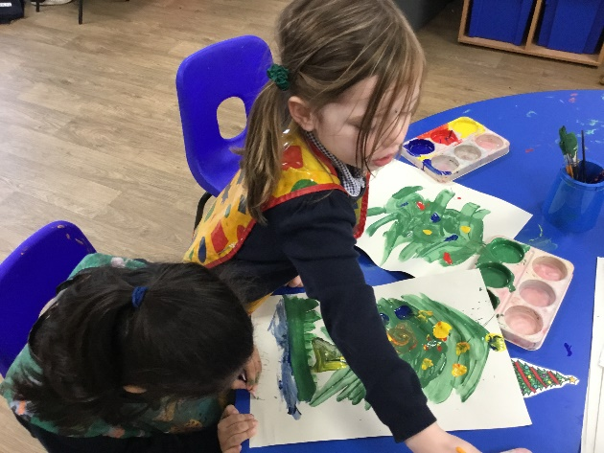
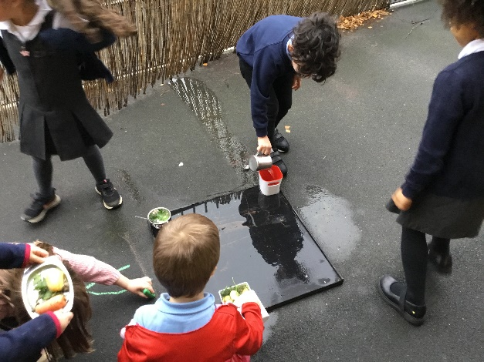

In planning and guiding children’s activities, great emphasis is placed on the different ways that children develop and learn.
The Characteristics of Effective Learning
- Playing and Exploring – children investigate and experience things, and ‘have a go’;
- Active Learning – children concentrate and keep on trying if they encounter difficulties, and enjoy achievements; and
- Creating and Thinking Critically – children have and develop their own ideas, make links between ideas, and develop strategies for doing things.
Through play in a secure but challenging environment with effective adult support, children can: explore, develop and represent learning experiences that help them to make sense of the world; practise and build up ideas, concepts and skills; learn how to understand the need for rules; take risks and make mistakes; think creatively and imaginatively; communicate with others as they investigate or solve problems.

Communication and Language
This area is divided into two sub areas: Listening, Attention and Understanding and Speaking.
At Haydn, our aim is to nurture and inspire in children a love of language, books and storytelling. Through a variety of fun and engaging activities and experiences, children learn and practise the skills that form the foundations for reading and writing. They explore and learn through singing and saying rhymes, making up and listening to music, playing games that develop a sense of rhythm, talking with others, sharing books with adults and other children, role playing, experimenting with writing and using actions, puppets and toys to retell and make up stories. Children are explicitly taught what it means to be a good listener and encouraged to tune into different sounds and begin to discriminate between them.
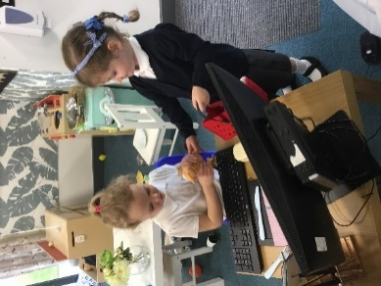

Personal, Social and Emotional Development
This area is divided into three sub areas: Self-Regulation, Managing Self and Building Relationships.
Children will explore their own feelings and those of others. They will be encouraged to become confident within the setting, accessing equipment and resources independently and becoming increasingly responsible for their self-care. Behaviour expectations will be introduced and children will become familiar with routines and rules of our setting.
Physical Development
This area of learning has 2 sub divisions: Gross Motor Skills and Fine Motor Skills.
Children will become aware of their own space and learn to move with control and coordination. They will have access to a variety of tools and learn to use these safely and with control. Children will learn to hold a pencil correctly with a tripod grip and use it to form recognisable letters and draw with increasing detail and control
Literacy
This area incorporates Comprehension, Word Reading and Writing.

Children will have a language rich environment where they will be immersed in books and stories. They will have lots of opportunities for retelling stories and narratives using their own words and new vocabulary.

Your child will learn letter sounds and names through the daily systematic teaching of phonics alongside other language rich activities which allow them to follow up, practise and remember these letter sounds in meaningful and purposeful contexts. They will have their own reading books that they will read with their teachers in school and their families at home. Children will be given many opportunities indoors and outside, to make marks and to learn to write for different purposes both as part of their play and during focused teaching activities. As they progress through the foundation stage the children will learn to form letters correctly and will be encouraged to write labels, captions and short sentences using their phonic knowledge.
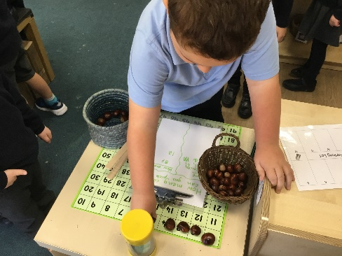

Mathematics
This area of learning has two subdivisions: Number and Numerical Patterns.
We believe that mathematics should be an enjoyable and exciting part of children’s learning and experience. The children undertake practical tasks which involve matching, sorting and counting. By the end of F2 most children will have an understanding of numbers to 10, linking names of numbers, numerals, their value, and their position in the counting order and will be able to automatically recall number bonds for numbers 0-5 and for 10 as well as automatically recall double facts up to 5+5; compare sets of objects up to 10 in different contexts, considering size and difference; and explore patterns of numbers within numbers up to 10, including evens and odds.
As they progress through the school they will be involved in both practical and more formal activities. At all ages they are encouraged to choose the equipment necessary to solve problems, to talk about their understanding, to explain their findings and to record their work in writing, making marks and drawings to represent their ideas and understanding.
Understanding of the World
This area of learning has three subdivisions: Past and Present; People, Culture and Communities; and The Natural World
Understanding of the world involves guiding children to make sense of their physical world and their community through opportunities to explore, observe and find out about different people and cultures, differences between the past and the present, places that are known to them and places that are new to them and the natural world around them.
Expressive Arts and Design
This area of learning has two subdivisions: Creating with Materials and Being Imaginative and Expressive
Our learning environments support children to explore and play with a wide range of media and materials, as well as providing opportunities and encouragement for sharing their thoughts, ideas and feelings through a variety of activities in art, music, movement, dance, role-play, and design and technology.
In Nursery and Reception, we follow children’s interests to offer them a stimulating and engaging curriculum. We use these interests alongside seasonal and story inspired topics and themes to teach the 7 areas of learning described above. Children are continually assessed through observations and focus groups and our reflections help to shape our provision for learning.

To do list!
- Return Admission Form and All About Me booklet to the school office. Don’t forget to bring your child’s birth certificate. Must be completed by Friday 27th June.
- Attend visit session on Tuesday 1st July.
- Week commencing 14th July, join Class Dojo and read the information/watch the videos.
- Have a fabulous summer holiday!
- Purchase school uniform and remember to label all the items.
- Attend half day sessions.
- Monday 8th September your child will start school full time. You are welcome to attend the coffee morning.

